**User Documentation -** Cloud Computing City

Player:  
In this game you can learn cloud computing from the basic level to the advanced level. You will manage a cloud company; your goal is to be the biggest business in the city. To achieve that you will have to see videos, answer multi choice questions, and get score to increase your company rank and became the best CEO in the city.

Admin:  
You will be able to add new questions, to edit/delete questions and to add new videos.

**Welcome screen:**

* Press on Log In button to move to Log In page.
* Press on Sign Up button to move to Sign Up page.



**Log In screen:**

* Enter username and password.
* Click on Connect to log in to the game.
* Click on Sign Up button if you don't have an account.
* Click on Back button to go back to Welcome screen.
* Note: by not entering all the fields or entering wrong username/password and click on Connect, the user gets an error message.



**Sign Up screen:**

* Enter username and password.
* Click on Create Account button.
* If you don't want to sign up, click on Back button to go back to Welcome screen.
* Note: by not entering all the fields or entering a username that already in use, the user gets an error message.



**Home screen:**

* You can see your name, your total score and your record of questions that answered correctly in a row.
* You can see you badge (if you are one of the top 3 users)
* Click on Leader Table button to see you rank and top 5 users.
* Click on Cinema button to watch and lean new fields related to cloud computing.
* Click on Help button to get more information about the game.
* Click on the dropdown to select the number of questions you want to play in current session.
* Click on Start button to start a game.
* Click on Logout button logout from the game.

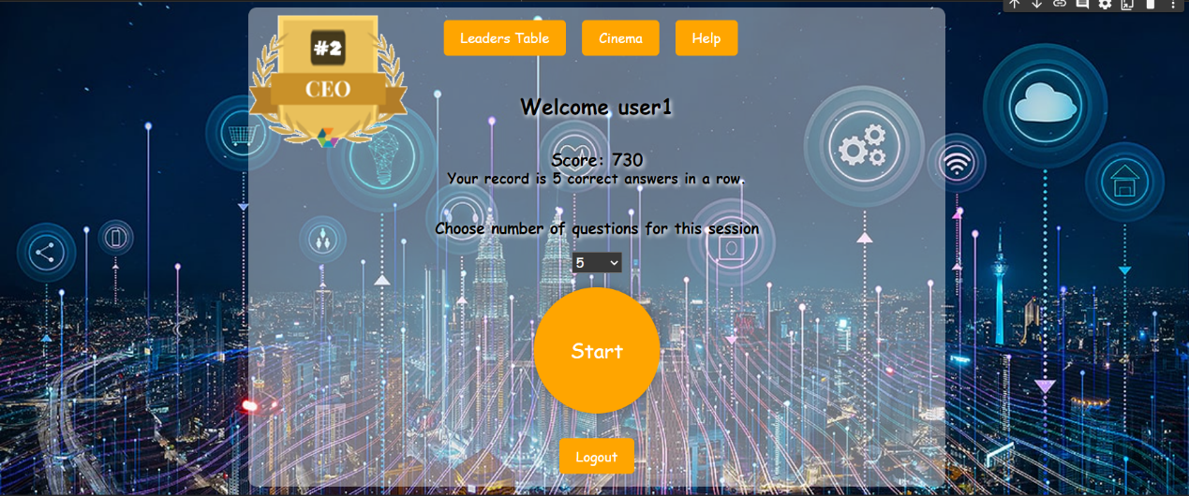

**The badges a user can get:**

|  |  |  |
| --- | --- | --- |
| **First Place** | **Second Place** | **Third Place** |
|  |  |  |

**Leader Table screen:**

* User can see his rank and the top 5 users.
* The user row in the table is marked.
* Note: if the user is not in the top 5, he still gone a see his rank in the last row in the table.

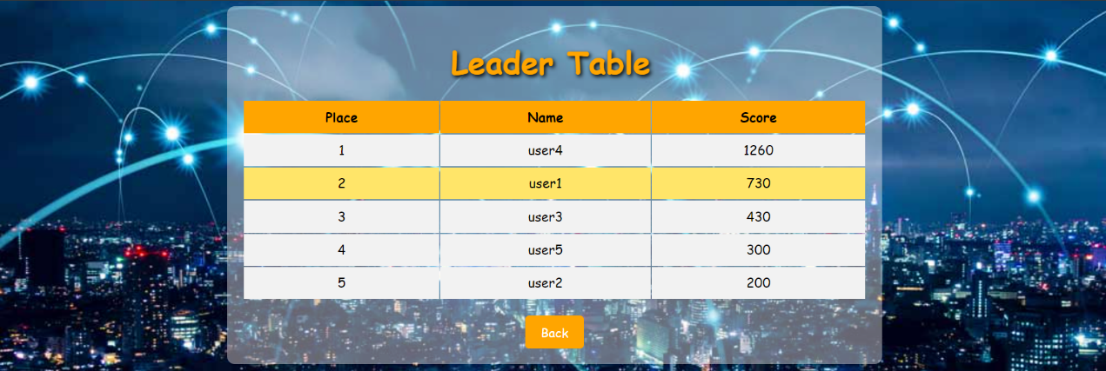

**Cinema screen:**

* Click on Watch button to see the video you want.
* Each video contains a title that related to the video.
* Click on Help button to get more information.

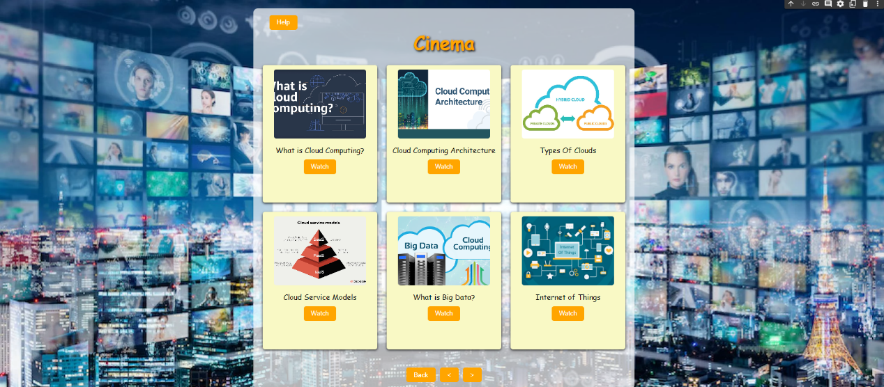

**Help pop-up in Home screen:**

* You can see more information about the game.

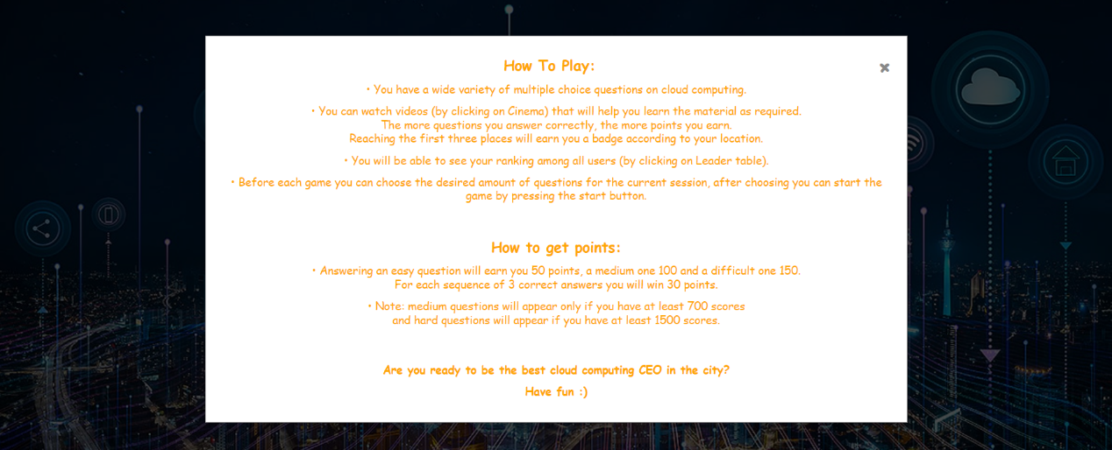

**Game screen:**

* You can see the number of questions you have in that session and the number of questions that you answered.
* You can see the question level.
* You can see the question and the four answers.
* To choose an answer click on that answer.

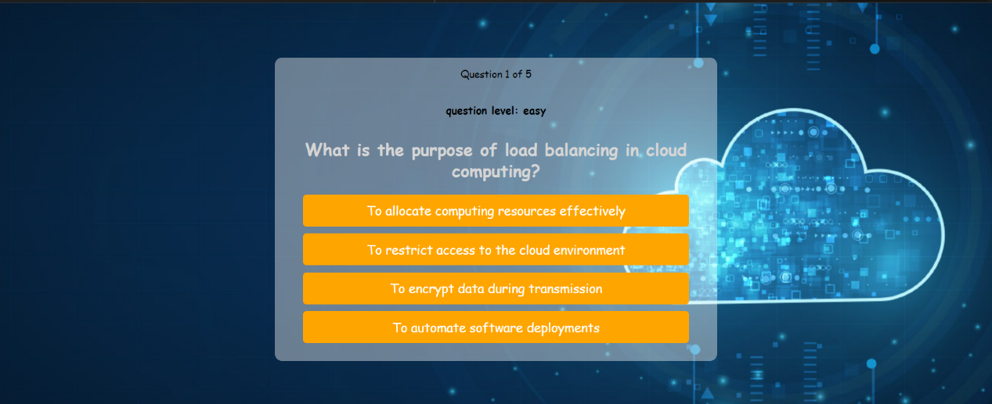

**Pop-up indicator in Game screen:**

* You can see if you right or wrong according to the display message.
* Click on Next Question to move on to the next question in the session.
* Click on the End Game button if you want to end your session in the middle.
* Note: in the screen below the shown pop-up is for correct answer.

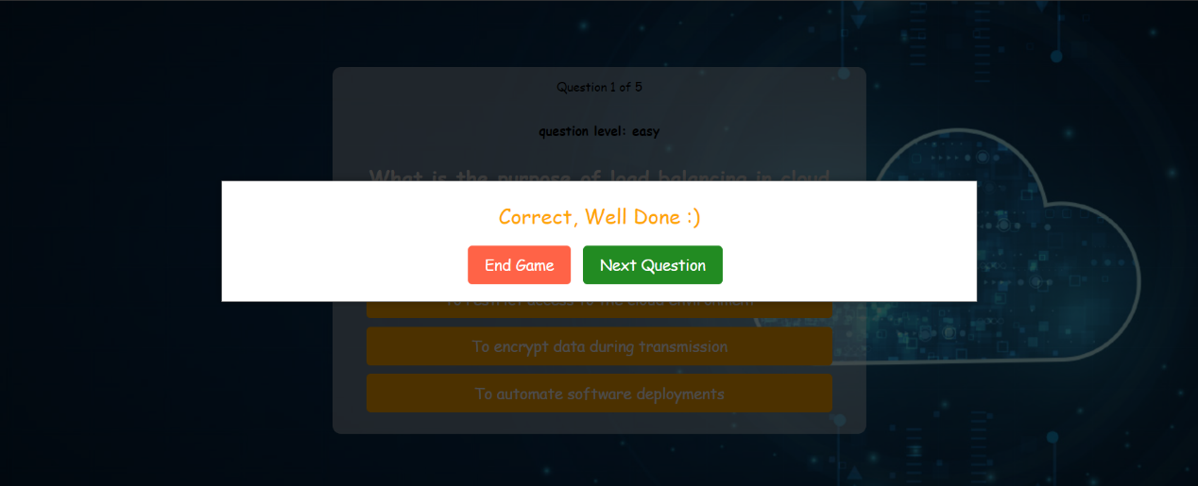

**Result screen:**

* Here you can see a summery for your session.
* You can see the number of questions that you answered correct.
* You can see how much score you got on that session.
* You can see how much questions you answered correct on a row.
* You can see how much time you play on that session.
* In the pie chart you can see in percentages the number of questions you answered correctly compared to the ones you got wrong.
* In the bar chart you can see how much score you got in your previous sessions (up to 3). The horizontal axis contains the session number, and the vertical axis contains the points for that session.
* Click on Back to Home Back to return to Home screen.

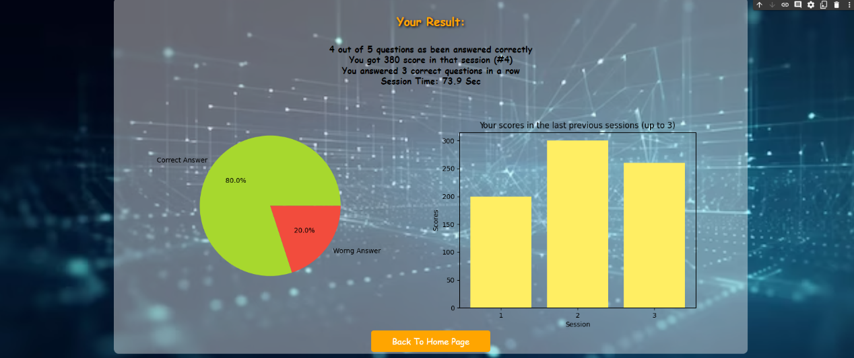

**Admin screen:**

* Click on Add question button to add a new question.
* Click on Edit question button to edit/delete question.
* Click on Add question button to add new video to the Cinema.
* Click on Logout to logout from the system.

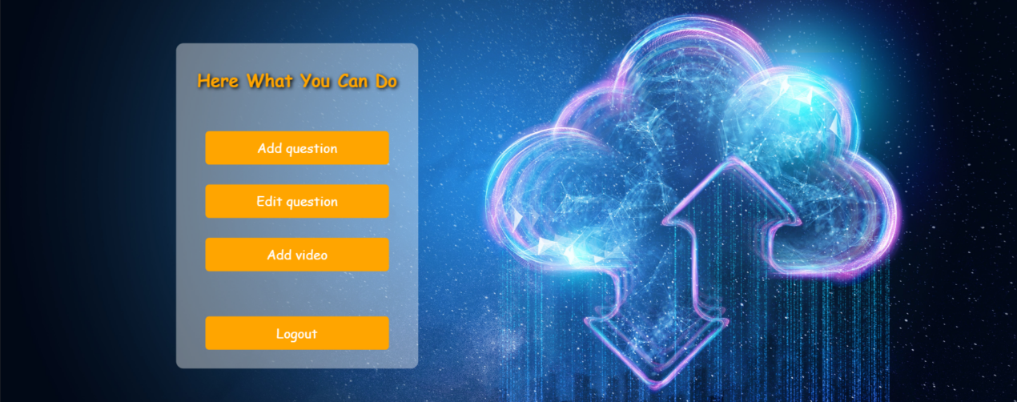

**Add Question screen:**

* Enter the question contact, option 1, option 2, option 3 and option 4.
* Choose from the correct dropdown the number of the correct option.
* Choose from the level dropdown the level of the question.
* Click on Add question to add that new question's data.
* Click on Back to return to Admin screen.
* Note: by not entering all the fields, the user gets an error message.

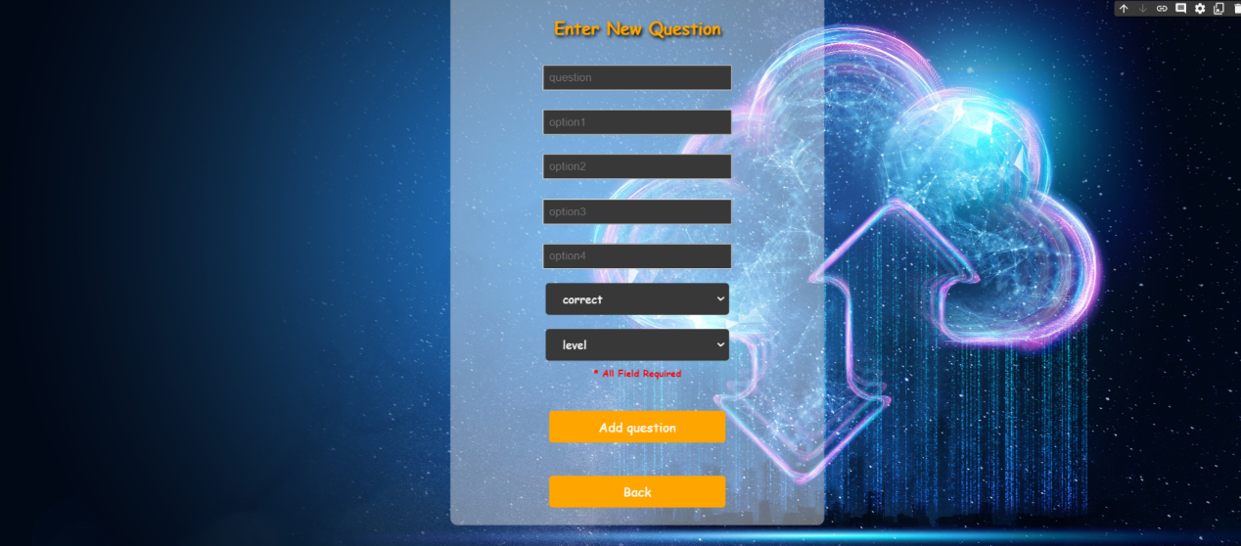

**Edit/Delete screen:**

* Choose a question form the dropdown.
* Click on Search to edit/delete the chosen question.
* Click on Back button to return to Admin screen.

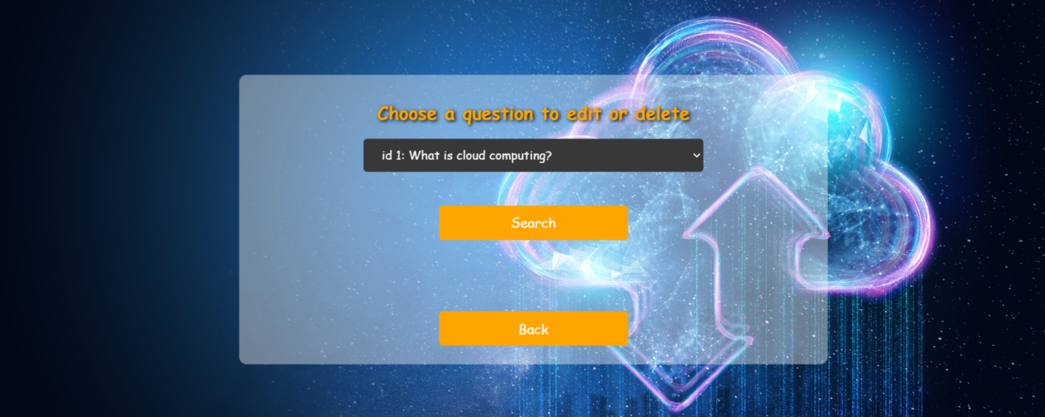

**Dropdown in the Edit/Delete screen:**

* You can see every question and its id.

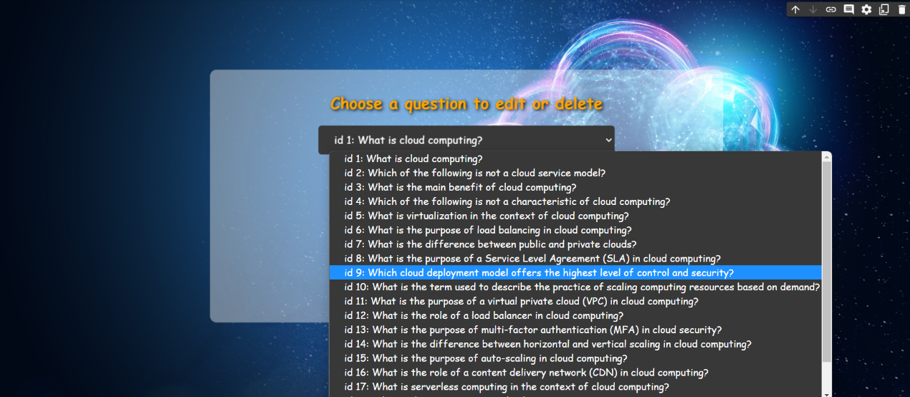

**Edit/Delete screen (after clicking on Search button):**

* If you want to edit the question data, enter the question contact, option 1, option 2, option 3 and option 4.
* Choose from the correct dropdown the number of the correct option.
* Choose from the level dropdown the level of the question.
* Click the Done button.
* If you want to delete that question, click on Delete button.
* Click on Back button to return to Edit/Delete screen (the screen above)
* Note: by not entering all the fields, the user gets an error message.

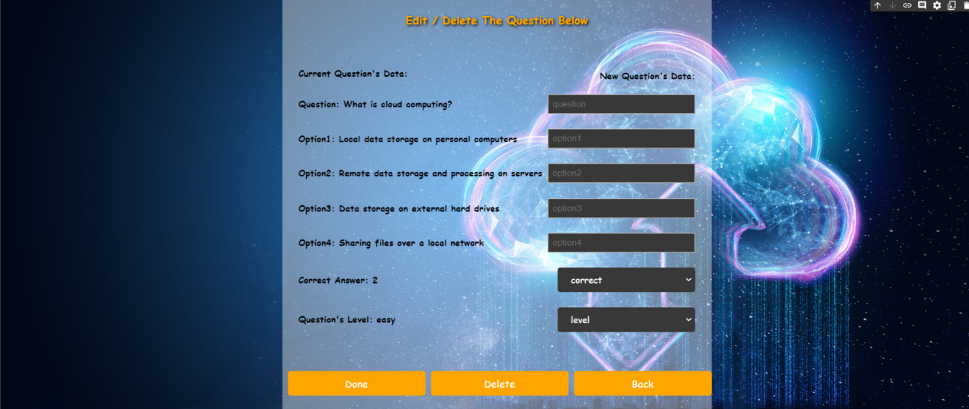

**Add Video screen:**

* Enter the image video, the title of the video and the video URL.
* Click on Add video button to add that.
* Click on Back button to return to Admin screen.
* Note: by not entering all the fields, the user gets an error message.

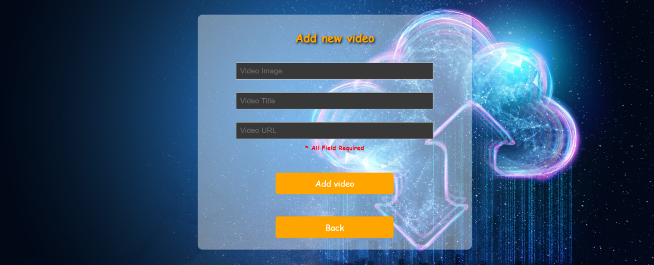

**Success pop-up:**

* After each successful action that admin does (add question, edit/delete question and add new video) he receives an appropriate message.
* Note: in the screen below the pop up that shown is after adding new video.

